**Current State:**

We’ve divided our total project into three stages. Such as 1) Building Drone 2) Integrating sensors and 3) Data collecting and analysis.

**Drone Building:**

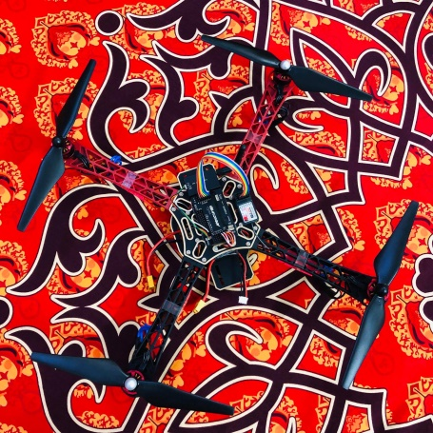

We've done building our drone in EEE499A. This is the main part of the project. It will travel through a specific area, track down the specific area of the pollution and will return back to the station. As it follows the specific path so it is very easy to get all the updated condition of any specific area. It is cost effective too. Here we are using four brushless motor, Per motor draws 2A while hovering. So 4 motor draws 8A for hovering in the air. Our selected battery is 2.2Ampere/hour. That means it cans delivery 2.2A for 1 hour (60minutes).

The calculation,

2.2A delivers 60 minutes 1A delivers 60x2.2 minutes 8A delivers (60x2.2)/12 minutes =16.5 minutes (theoretically, moderate air condition) Practically it varies from 12-14 minutes.

Theoretically, the range of our drone is 1KM, but practically it varies from 600-800 meters depending on the weather. Transmitter to the receiver has to communicate via 2.4Ghz. 6 individual channel, means 6 separate PWM values. But technically it shows some variations. Usually, we use 'mission planner' from the laptop or 'Droid planner' from mobile to select the specific path for the Drone, But in case of an error, we alternatively use a remote to control The drone. We give the input from Mobile/Laptop then it flies accordingly and returns at the same place.

We use Soldering iron, Screw box, Hex screw, Double side tape as supporting tools. Still, We didn't integrate the sensor part with the drone. We are practicing over it, recording the challenges and the limitations of it.

**Sensor Part:**

Sensor part is our main external circuit which will be integrated with drone. The purpose of this circuit is to detect the pollutants from the air. For which we are using several gas sensors for detecting gases and PM (Particulate Matter) Sensor for detecting dust pollutants. We also use a camera for taking the structural views so that we can conclude for what reason the pollutants varies over time. We are done with making the circuit. Currently we are testing the sensitivity of the sensors (record the response of the sensors by making artificial pollutants). After that we will integrate it with the drone and will measure the data in various place of Dhaka city. We are offering a cost effective and reliable solution using low cost sensors.